TEMPLATE
The 7-box structure (with “why this, not that?”)
1) Users & Authentication → Cognito (User Pools) + JWT
When you see: “login”, “requires authentication”, “premium users”, “accounts”, “password reset”, “MFA”.
What it does (super simple):
Cognito is the bouncer at the club. It checks who you are and gives you a stamp (a JWT token). Then your API can trust the stamp.
Why Cognito (instead of doing it yourself)?
- You don’t want to build registration/login/reset-password/MFA yourself → it’s error-prone and time-consuming.
- Cognito is managed: scaling and security are handled.
Why not IAM?
IAM is for developers / AWS access, not your app’s customers.
Why not “store users in RDS”?
You can, but then you must implement hashing, password resets, token issuing, MFA, etc. That’s a lot of security risk.

2) Frontend delivery (Angular/React) → S3 static hosting + CloudFront
When you see: “Angular frontend”, “React frontend”, “static files”, “global users”.
What it does:
- S3 stores your website files (HTML/CSS/JS).
- CloudFront is like having copies of your website near users worldwide, so it loads faster.
Why S3 for frontend (instead of EC2/ECS)?
- Frontend static files don’t need a server running code.
- EC2/ECS would mean you pay for always-on machines just to serve files → waste.
Why CloudFront (instead of “just S3”)?
- S3 is in one region. Users far away may have slower access.
- CloudFront caches at edge locations worldwide → faster and usually cheaper at scale.

3) API entry point → API Gateway (often) OR ALB (sometimes)
When you see: “public API”, “partners”, “expose API”, “rate limits”, “API keys”.
What it does:
API Gateway is the front desk for your API. It can:
- route requests to services
- enforce auth
- throttle/rate limit
- handle API keys and usage plans (if needed)
Why API Gateway (instead of ALB)?
- ALB is mainly “send traffic to servers/services”.
- API Gateway is “API product”: auth integration, throttling, versioning, monitoring for APIs.
When ALB is enough:
If it’s just a normal web backend and you don’t need “API management features”, ALB in front of ECS/EC2 can be simpler.

4) Compute (backend / workers) → choose by workload
Option A: Lambda
When you see: event-driven, short tasks, unpredictable traffic, “only sometimes”, glue code.
Why Lambda: You pay only when it runs. No servers to manage.
Why not Lambda:
- Long heavy jobs (like training/transcoding) can be awkward/expensive or hit limits.
- If you need custom runtime + heavy dependencies, containers may be nicer.
Option B: ECS Fargate
When you see: “backend in Node/C++”, “Docker”, “reduce ops”, “long-running service”.
Why Fargate: You run containers but AWS manages the servers.
Why not EC2:
EC2 means you manage patching, scaling groups, capacity, etc.
Option C: EC2
When you see: “we need full control”, “special networking”, “custom setup”, “legacy app”.
Why EC2: Maximum control.
Why not EC2 (for small team):
Most operational work (updates, scaling, monitoring, failures).

5) Data stores (separate by file type)
Large files → S3
When you see: CSVs, videos, images, datasets, uploads.
Why S3:
It’s built for storing huge files cheaply and reliably.
Why not EBS/RDS for files:
- EBS is like a disk attached to one machine (not ideal for many users).
- RDS is for structured relational data, not big blobs/files.
Relational data → RDS (PostgreSQL/MySQL)
When you see: “PostgreSQL”, “transactions”, “users/projects/jobs table”.
Why RDS (instead of running DB on EC2):
- AWS handles backups, patching, failover options, monitoring.
- Running PostgreSQL on EC2 = you become the database admin.

6) Async processing & notifications → SQS + workers, SNS for fan-out, SES for email
When you see: “not latency critical”, “background processing”, “pipeline”, “notify when ready”.
SQS (Queue)
What it is: A waiting line. Jobs wait here safely.
Why SQS:
- If 1,000 jobs come at once, your system doesn’t crash — they just queue.
- Workers process at their speed.
Why not “call the worker directly”?
Direct calls can overload your system → failures and timeouts.
SNS (Topic)
What it is: A megaphone. One message → many subscribers.
Why SNS:
If you want to notify multiple things (email + webhook + logs), SNS is clean.
SES
What it is: Email sending service.
Why SES (instead of your app sending emails directly):
Email delivery is painful (reputation, throttling, bounces). SES is built for it.

7) Security & Networking → VPC + private subnets + Security Groups + IAM
When you see: anything serious, databases, “secure”, “private”, “only backend can access DB”.
What it does (dumb version):
- VPC = your private neighborhood
- Public subnet = stuff that must face the internet (ALB/API Gateway integration points)
- Private subnet = stuff that should NOT be exposed (DB, workers)
- Security groups = “who is allowed to talk to whom on which port”
- IAM roles = “what AWS permissions this service has”
Why security groups (instead of IP allowlists)?
Because instances/tasks change IPs when autoscaling.
Security group → security group rules still work even when IPs change.

Mini-rule you can memorize
If the exercise says:
- “small team / reduce ops” → prefer managed services: Cognito, RDS, S3, CloudFront, Fargate, Lambda, SQS/SNS.
- “global users / sharing worldwide” → CloudFront.
- “background processing / notify when done” → SQS + worker + SNS/SES.
- “public API for partners” → API Gateway.

EXERCISES
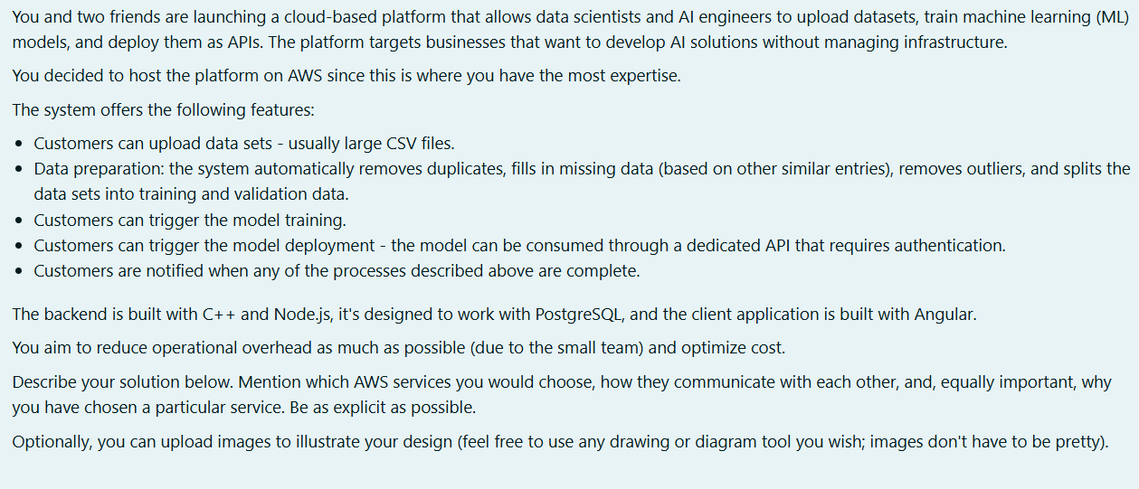
1) Frontend (Angular)
S3 (static website hosting) + CloudFront
- S3 hosts Angular build files (HTML/CSS/JS).
Why S3 vs EC2? Because a static site doesn’t need a server; EC2 would be “paying for a running computer just to serve files”.
- CloudFront caches the site globally.
Why CloudFront vs only S3? Faster worldwide, less latency for global users.
2) Authentication (users + secured APIs)
Amazon Cognito User Pool (OAuth/JWT tokens)
- Cognito handles sign-up/sign-in, password resets, MFA, token issuing.
- Why Cognito vs “do it ourselves in Node + RDS”? Auth is easy to mess up; Cognito removes most security work and scales automatically.
3) API entry point (“public API” + authenticated access)
Amazon API Gateway
- Exposes endpoints like: /datasets, /prep, /train, /deploy, /status, /predict
- Validates Cognito JWT tokens before requests reach backend.
- Why API Gateway vs only ALB? ALB is mostly “traffic forwarding”. API Gateway is built for “API product” features (auth integration, throttling/rate limits, API keys if needed).
4) Core backend compute (C++ + Node.js)
ECS Fargate (containers) + ECR (container registry)
- Package C++ + Node services as Docker images, store in ECR, run on ECS Fargate.
- Why Fargate vs EC2? EC2 means we manage servers/patching/capacity. Fargate means AWS manages the servers → less ops.
You can split backend into:
- Control-plane API service (Node.js): creates jobs, writes metadata, returns statuses
- Worker services (C++/Node): do prep/training/inference tasks
5) Data stores
S3 for files + RDS PostgreSQL for metadata
- S3 buckets:
  - raw uploads (CSV)
  - prepared datasets
  - trained model artifacts
  - logs/results
Why S3? Cheap, durable, best for large files.
- RDS PostgreSQL (Multi-AZ):
  - users/projects/dataset metadata
  - job state: QUEUED/RUNNING/DONE/FAILED
  - model versions + deployment info
Why RDS vs running Postgres on EC2? RDS handles backups/patching/failover → low ops.
6) Async processing + notifications
SQS + Step Functions + SNS/SES
- SQS queues decouple the system:
  - prep-queue, train-queue, deploy-queue
Why SQS? If 200 jobs arrive at once, you don’t crash; they wait in line.
- Step Functions orchestrates the workflow (prep → train → deploy), including retries and failure handling.
Why Step Functions? Otherwise you write messy custom orchestration logic in your backend.
- SNS + SES for notifications:
  - publish “job completed/failed” to SNS
  - email via SES (triggered by Lambda or a small notification service)
Why SNS? One message can notify multiple things (email, webhook, audit logs) easily.
7) Networking & security (default “safe architecture”)
VPC + private subnets + security groups + IAM roles + Secrets Manager
- Put RDS in private subnets (no public internet access).
- ECS tasks can run in private subnets too.
- Security groups:
  - DB SG allows inbound Postgres (5432) only from ECS app SG
- IAM roles:
  - backend role can read/write specific S3 buckets, send SQS messages, publish SNS, read Secrets Manager
- Secrets Manager stores DB credentials.
- Optional cost/security improvement: VPC endpoints for S3 so traffic stays private and reduces NAT cost.

End-to-end workflow template
1) UI: User loads the Angular app from CloudFront → S3.
2) Login: User authenticates with Cognito and receives a JWT.
3) API call: Frontend calls API Gateway with JWT (e.g., upload/train/deploy).
4) Upload files: Backend returns pre-signed S3 URL → user uploads dataset to S3.
5) Create job: Backend writes job + metadata to RDS and starts workflow (Step Functions) or enqueues to SQS.
6) Process job: ECS Fargate workers pull from SQS (or StepFn triggers them) and run prep/train/deploy, storing outputs in S3 and updating status in RDS.
7) Notify: On success/failure, worker publishes to SNS → email sent via SES.
8) Consume: Model API is exposed via API Gateway (JWT required) routing to the inference service (ECS Fargate).

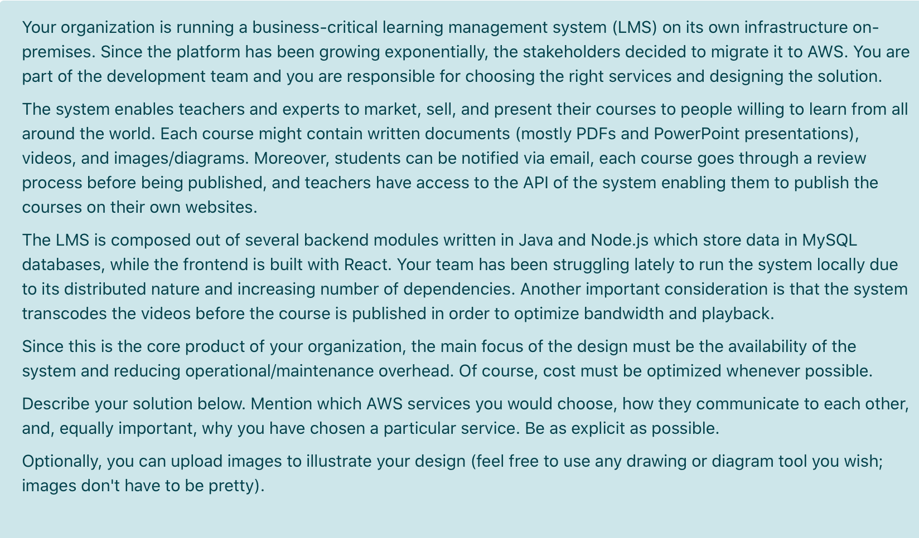
1) Users & Authentication
Amazon Cognito (User Pools)
- Handles sign-up/sign-in, tokens (JWT), password reset, MFA.
- Why Cognito vs custom auth in app/DB? Less security code + scales automatically.

2) Frontend delivery (React)
S3 + CloudFront
- React build is static → host on S3.
- CloudFront caches globally for fast access.
- Why not EC2 for frontend? Paying for servers just to serve files.

3) API entry point
API Gateway
- Exposes LMS API to web app + teachers’ websites (partner/public usage).
- Integrates with Cognito authorizer (JWT) + throttling/rate limiting if needed.
- Why API Gateway vs only ALB? API Gateway is better for “public API management”.

4) Compute (Java + Node modules)
ECS Fargate + ECR (and optional ALB internally)
- Containerize backend modules (Java/Node) → push images to ECR, run on ECS Fargate.
- Why Fargate vs EC2? AWS manages servers/patching/capacity → lower ops.
- For internal routing/load balancing between services: ALB in front of ECS services if needed.

5) Data stores
S3 for course content + RDS/Aurora MySQL for relational data
- S3 stores PDFs, PPTs, images, raw videos, transcoded videos.
  - Why S3? Cheap + durable + built for large objects.
- Amazon RDS (MySQL) or Aurora MySQL stores users/courses/enrollments/orders/review status metadata.
  - Why RDS/Aurora vs MySQL on EC2? Backups, patching, failover handled (low ops).
  - If “business critical + high availability” is emphasized: Aurora is a strong choice.

6) Async processing & notifications (review + transcoding + email)
SQS + Step Functions + SNS/SES
- SQS queues for background work:
  - review-queue (if approvals are async)
  - transcode-queue (video processing jobs)
- Step Functions orchestrates: upload → review → transcode → publish (with retries/fail states)
- SNS + SES for email notifications:
  - publish “course approved / video ready” to SNS
  - email students via SES
- Why SQS? Buffers spikes, prevents overload.
- Why Step Functions? Clean workflow without custom orchestration logic.
Transcoding compute: use ECS Fargate worker containers (ffmpeg etc.) reading from SQS, writing outputs to S3. (Low ops, flexible runtime.)

7) Networking & security
VPC + private subnets + security groups + IAM roles + Secrets Manager
- Put DB in private subnets (no public access).
- ECS services/workers in private subnets; API Gateway integrates to them (via VPC link if needed) or via ALB.
- SG rule: DB allows MySQL (3306) only from app SG.
- Secrets Manager stores DB credentials.
- IAM roles: app can read/write S3, send SQS, publish SNS, read secrets.
- Optional: S3 VPC endpoint to reduce NAT cost and keep traffic private.

End-to-end workflow template (same structure, LMS version)
- UI: User loads the React app from CloudFront → S3.
- Login: User authenticates with Cognito and receives a JWT.
- API call: Frontend (and teachers’ websites) call API Gateway with JWT (e.g., create course, upload content, publish).
- Upload files: Backend returns a pre-signed S3 URL → teacher uploads PDF/PPT/images/videos to S3.
- Create job: Backend writes course + review status + content metadata to RDS/Aurora MySQL and starts the workflow (Step Functions) or enqueues to SQS.
- Process job: ECS Fargate workers pull from SQS (or Step Functions triggers them) and run review steps + video transcoding, storing outputs in S3 and updating status in RDS/Aurora.
- Notify: On approval/publish/transcode completion, worker publishes to SNS → email via SES to students/teachers.
- Consume: Students consume content via CloudFront → S3 (fast global delivery), while LMS operations go through API Gateway.

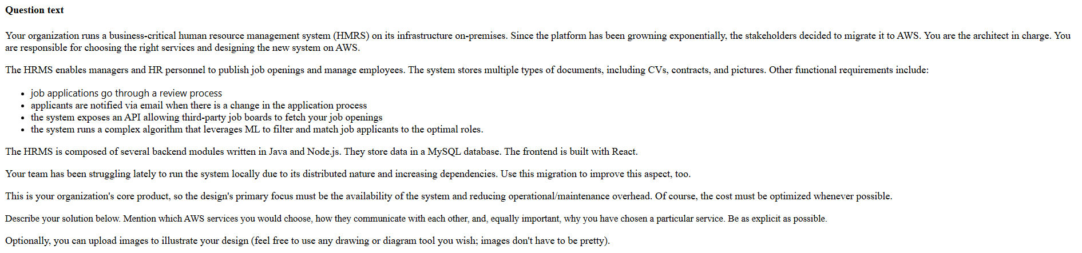
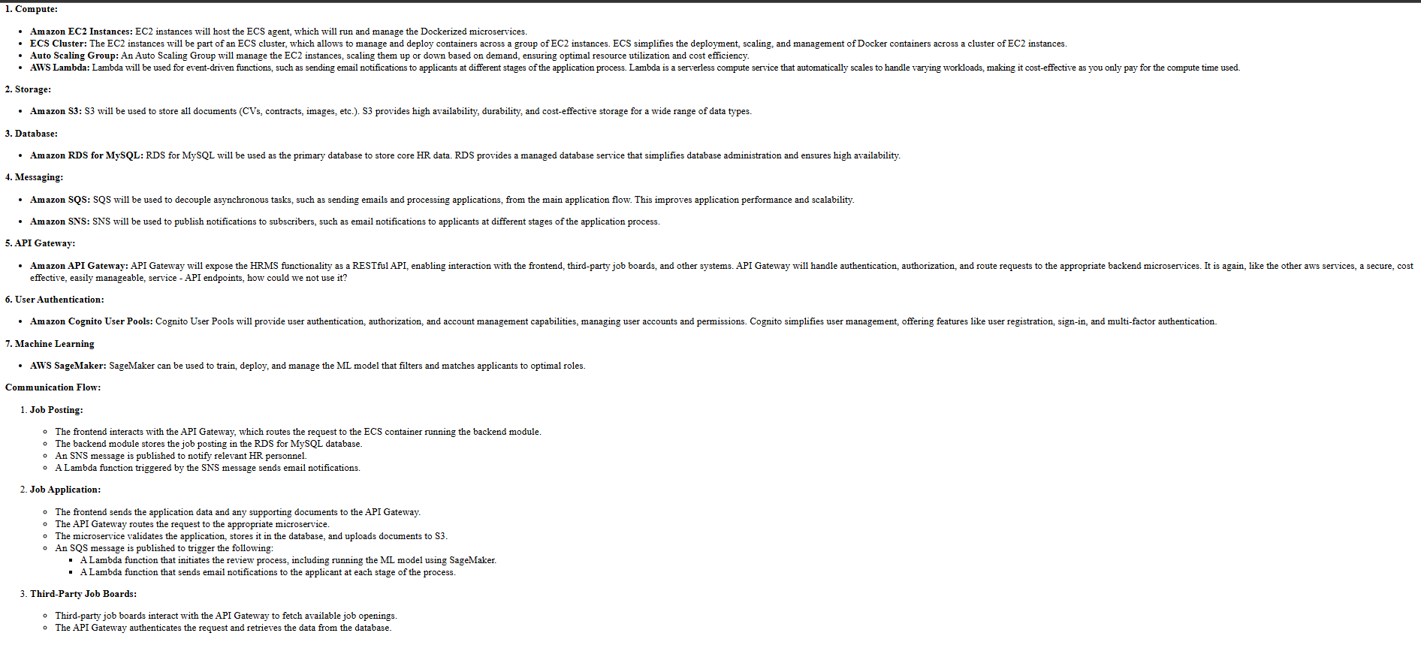
1) Users & Authentication
Amazon Cognito (User Pools)
- HR managers, applicants, and job-board integrations authenticate via tokens (JWT).
- Why Cognito? Saves you from building/maintaining secure auth logic; scales automatically.

2) Frontend delivery (React)
S3 + CloudFront
- React is static files → host on S3.
- Global access + speed → CloudFront CDN caches at edge.
- Why not EC2 for frontend? Static site doesn’t need servers (lower ops + cheaper).

3) API entry point (public API for job boards)
API Gateway
- Expose endpoints like: /jobs (public read), /apply, /status, /admin, /webhooks
- Integrate Cognito authorizer for protected endpoints; optionally API keys/rate limits for job boards.
- Why API Gateway vs only ALB? API Gateway is designed for public APIs (auth, throttling, keys, monitoring).

4) Compute (Java + Node modules)
ECS Fargate + ECR
- Containerize Java/Node services → store images in ECR → run on Fargate.
- Why Fargate vs EC2? No server management/patching/capacity planning → less ops.
- Split services (conceptually):
  - HRMS API service (CRUD jobs, applications, reviews)
  - Background worker (email events, ML matching triggers)

5) Data stores (separate by type)
S3 for documents + RDS/Aurora MySQL for relational data
- S3 stores CVs/contracts/pictures (large objects).
  - Why S3? Cheap, durable, scalable object storage.
- RDS MySQL (Multi-AZ) or Aurora MySQL stores:
  - users, jobs, applications, review states
  - audit/history of application status changes
  - ML scores / match results metadata
  - Why RDS/Aurora vs MySQL on EC2? Managed backups/patching/failover → low ops + higher availability.

6) Async processing + notifications + ML
SQS + Step Functions + SNS/SES + (SageMaker for ML)
- SQS queues decouple heavy/async work:
  - review-queue (if approvals happen async)
  - status-change-queue (email pipeline)
  - ml-matching-queue (run matching algorithm)
  - Why SQS? Spikes won’t crash services; jobs wait reliably.
- Step Functions orchestrates business flows (optional but strong):
  - “application submitted → review → decision → notify”
  - retries + failure handling without custom code
- Notifications: SNS → SES
  - publish “application status changed” to SNS
  - send email via SES
- ML matching: Amazon SageMaker (best “managed” story)
  - train/host the matching model as an endpoint, or run batch inference jobs
  - HRMS backend calls the endpoint to get match scores
  - Why SageMaker vs running ML on ECS manually? Less ML infra to manage, scalable, purpose-built.
(If your course didn’t cover SageMaker much, you can say “ECS worker does ML matching”, but SageMaker usually scores higher.)

7) Networking & security
VPC + private subnets + security groups + IAM roles + Secrets Manager
- RDS in private subnets (no public internet access).
- ECS tasks in private subnets.
- Security group rule: DB (3306) only from ECS app SG.
- IAM roles for services: least privilege to S3/SQS/SNS/Secrets.
- Secrets Manager stores DB credentials.
- Optional: S3 VPC endpoint (reduce NAT cost, keep traffic private).

C) End-to-end workflow (same template, HRMS version)
- UI: User loads React app from CloudFront → S3.
- Login: User authenticates with Cognito and receives a JWT.
- API call: Frontend + job boards call API Gateway (public /jobs, protected endpoints require JWT / API key).
- Upload files: Backend returns pre-signed S3 URL → applicant uploads CV/contract/picture to S3.
- Create job: Backend writes application/job + status to RDS/Aurora MySQL and enqueues events to SQS (review / email / ML).
- Process job: ECS Fargate workers pull from SQS to run review workflow steps, call SageMaker for matching (or run matching logic), update results/status in DB.
- Notify: Worker publishes “status changed” to SNS → email via SES to applicant.
- Consume: Job boards fetch postings via API Gateway, HR users manage applications via the React UI + API.

